 | MEENAKSHI SUNDARARAJAN ENGINEERING COLLEGE  Kodambakkam, Chennai-600024 | 

NM1009 –GENERATIVE AI FOR ENGINEERING

DEPARTMENT OF COMPUTER SCIENCE AND ENGINEERING

TOPIC: DALL-E Image Generator Using OpenAI, Flask & Replit

FACULTY MENTOR: | Dr. S.AARTHI
Project submitted by,
KARTHIGAI KANNAN K (311521104024)

CONTENTS
- ABSTRACT
- INTRODUCTION
- PROJECT OVERVIEW
- SYSTEM ARCHITECTURE
- INSTALLATION GUIDE
- USAGE INSTRUCTION
- FRONTEND IMPLEMENTATION
- BACKEND IMPLEMENTATION
- DEPLOYMENT
- ADVANTAGES AND DISADVANTAGES
- CONCLUSION
- FUTURE SCOPE
OUTPUT FOR SOURCE CODE
APPENDIX

ABSTRACT:

The Dall-E Image Generator project is a web-based platform that leverages OpenAI's Dall-E model to generate images from textual prompts. The project combines frontend technologies such as HTML, CSS, and JavaScript for the user interface with Python Flask for the backend logic. Users can input textual descriptions through a simple web form, and the backend interacts with the OpenAI API to generate corresponding images. The generated images are then displayed back to the users in the web interface. The project aims to provide a user-friendly and accessible tool for creative exploration and artistic expression, enabling users to visually depict their textual ideas and prompts. Additionally, the project offers opportunities for future expansion and enhancement, including improvements in user interface design, model fine-tuning, customization options, and integration with external platforms. Overall, the Dall-E Image Generator project represents a novel application of AI-driven image synthesis technology, offering users a unique and engaging experience in the realm of generative art and creativity.

INTRODUCTION

The DALL-E Image Generator project aims to bridge the gap between textual descriptions and visual representations by leveraging the power of artificial intelligence. Inspired by the groundbreaking work of OpenAI's DALL-E model, this project showcases how advanced AI models can be integrated into web applications to enable users to generate unique and imaginative images based on their written prompts.
In this documentation, we will delve deeper into the various aspects of the DALL-E Image Generator, including its architecture, installation process, usage instructions, error handling mechanisms, user interface design, code optimization techniques, and more. By providing comprehensive guidance, we aim to empower both developers and users to understand and utilize the application effectively.

PROJECT OVERVIEW

The DALL-E Image Generator project is built upon a client-server architecture, with the frontend developed using HTML, CSS, and JavaScript, and the backend powered by Python Flask. The key component of the project is the integration of

OpenAI's DALL-E API, which serves as the engine for generating images based on user-provided text prompts.

At its core, the project demonstrates the seamless interaction between human language and visual content, showcasing the potential of AI to understand and interpret textual descriptions in a creative and visually appealing manner. By enabling users to express their ideas through written prompts and transform them into tangible images, the DALL-E Image Generator opens up new possibilities for artistic expression and storytelling.

SYSTEM ARCHITECTURE

The system architecture of the DALL-E Image Generator is designed to be modular, scalable, and efficient. It consists of the following components:

- Frontend: The frontend interface is responsible for presenting the user with a form for inputting text prompts and displaying the generated images. It is implemented using HTML, CSS, and JavaScript to ensure a responsive and interactive user experience.

- Backend: The backend of the application is powered by Python Flask, a lightweight web framework for handling HTTP requests and responses. It acts as the intermediary between the frontend and the DALL-E API, processing user input, making requests to the API, and delivering the generated images back to the frontend.

- OpenAI DALL-E API: The DALL-E API provided by OpenAI is the core component responsible for generating images based on textual prompts. It utilizes state-of-the-art deep learning techniques to understand and interpret the semantics of the input text and generate corresponding visual outputs.

- Replit Hosting: The application is hosted on the Replit platform, which provides a cloud-based development environment and hosting solution. Replit offers seamless integration with Flask applications, making it easy to deploy and manage web applications in the cloud.

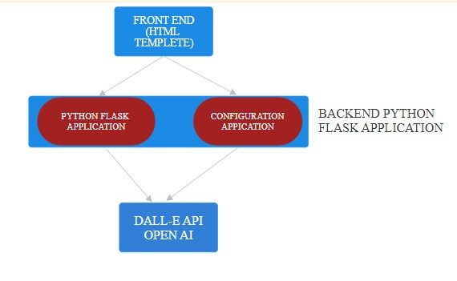

INSTALLATION GUIDE

Installing the DALL-E Image Generator locally or on Replit is a straightforward process that involves the following steps:

- Sign up for OpenAI API Access: Before getting started, users need to sign up for access to OpenAI's DALL-E API and obtain their API key. This key will be used to authenticate requests to the API.

- Create a New Flask Project: Users can choose to create a new Flask project either locally on their development machine or on the Replit platform. For local development, they will need to have Python installed along with the necessary dependencies (e.g., Flask, requests).

- Install Dependencies: Once the Flask project is set up, users need to install the required Python packages using pip. This includes Flask, requests, and any other dependencies specified in the project.

- Copy Source Code: Users can then copy the provided source code into their Flask application files. This includes the main Flask application file (main.py,config.py), as well as the HTML templates (index.html).

- Configure API Key: Users need to replace the placeholder 'YOUR_API_KEY' in the source code with their actual OpenAI API key. This ensures that requests to the DALL-E API are properly authenticated.

- Run the Application: Finally, users can run the Flask application either locally or on Replit. They can then access the application through the provided URL and start generating images based on their textual prompts.

By following these steps, users can quickly set up and deploy the DALL-E Image Generator and begin exploring its capabilities.

USAGE INSTRUCTION

Using the DALL-E Image Generator is a straightforward process that involves the following steps:

- Access the Application: Users can access the DALL-E Image Generator through a web browser by navigating to the provided URL. This will take them to the homepage of the application, where they can input their text prompts.

- Input Text Prompt: On the homepage, users will find a form where they can input their text prompt. They can enter any descriptive text they like, such as a short sentence or a longer paragraph describing the image they want to generate.

- Generate Image: After entering their text prompt, users can click the "Generate Image" button to submit the form. The application will then communicate with the DALL-E API to generate an image based on the provided text.

- View Generated Image: Once the image generation process is complete, the application will display the generated image on a separate result page. Users can view the image and download it if desired.

- Repeat as Desired: Users can repeat the process as many times as they like, generating new images by entering different text prompts each time. The application provides a seamless and intuitive experience for exploring the creative possibilities of AI-driven image generation.

FRONTEND IMPLEMENTATION:
The frontend of the Dall-E Image Generator project is designed to provide a user-friendly interface for interacting with the application. It is developed using HTML, CSS, and JavaScript to create an intuitive and visually appealing experience for users. Below are additional details about the frontend implementation:
- HTML Structure: The HTML template (index.html) defines the structure of the frontend interface. It includes elements such as input fields, buttons, and image containers to facilitate user interaction.

- CSS Styling: The CSS stylesheet (style.css) is used to enhance the visual presentation of the frontend interface. It defines styles for elements such as text formatting, layout positioning, and color schemes to create a cohesive design.

- JavaScript Interactivity: The JavaScript code (script.js) adds interactivity to the frontend interface. It handles user input events, such as form submissions and button clicks, to initiate requests to the backend server and update the interface dynamically.

- Form Submission Handling: When users enter textual prompts and submit the form, JavaScript code prevents the default form submission behavior and initiates an asynchronous request to the backend server using the Fetch API. This allows the application to fetch image generation results without reloading the page.

- Loading Indicator: To provide feedback to users while waiting for image generation results, a loading indicator is displayed using an animated GIF. The loading indicator is shown when a request is in progress and hidden once the response is received.

- Dynamic Content Update: Upon receiving the image generation results from the backend server, the JavaScript code dynamically updates the frontend interface to display the generated images. It iterates over the list of image URLs and creates HTML elements to render the images within the designated image containers.

- Error Handling: Although not explicitly implemented in the provided code snippet, error handling is an essential aspect of frontend development. Proper error handling ensures that users are informed of any issues that occur during the application's operation, such as network errors or invalid input, and provides guidance on how to resolve them.

- Responsive Design: For optimal user experience across different devices and screen sizes, the frontend interface can be designed with responsive principles in mind. This includes using responsive CSS techniques such as media queries to adjust layout and styling based on viewport dimensions.

BACKEND IMPLEMENTATION:
The backend of the Dall-E Image Generator project is developed using Python Flask, a lightweight web framework. It serves as the core logic behind handling user requests, interacting with the OpenAI API, and returning image generation results to the frontend. Below are additional details about the backend implementation:
- Flask Routes: The Flask application defines routes to handle different types of HTTP requests from the frontend. For example, the / route serves the HTML template for the frontend interface, while the /generateimages/<prompt> route handles requests for generating images based on textual prompts.

- OpenAI API Integration: The backend interacts with the OpenAI API to request image generation based on the textual prompts submitted by users. The API key required for authentication is securely stored in a configuration file (config.py) and accessed during runtime.

- Request Processing: When a user submits a textual prompt through the frontend interface, the corresponding route in the Flask application receives the request. The textual prompt is extracted from the request parameters and passed as input to the OpenAI API for image generation.

- Response Formatting: Upon receiving image generation results from the OpenAI API, the backend formats the response data into a JSON format and returns it to the frontend. The response typically includes a list of image URLs representing the generated images.

- Error Handling: Error handling is implemented to handle potential exceptions that may occur during request processing. This includes handling errors related to network connectivity issues, invalid input parameters, or errors returned by the OpenAI API. Proper error responses are returned to the frontend to inform users of any issues encountered.

- Security Considerations: The Flask application incorporates security best practices to ensure the integrity and confidentiality of user data. This includes measures such as input validation, sanitization of user input, and protection against common web vulnerabilities like Cross-Site Scripting (XSS) and Cross-Site Request Forgery (CSRF).

- Concurrency and Scalability: The backend architecture is designed to handle concurrent requests efficiently and scale to accommodate increased traffic as needed. Flask's lightweight nature and support for asynchronous request handling allow the application to scale horizontally by deploying multiple instances behind a load balancer.

DEPLOYMENT:
Deploying the Dall-E Image Generator project involves setting up the application to run in a production environment where it can be accessed by users over the internet. Below are additional details about the deployment process:

- Hosting Platform Selection: Choose a hosting platform that supports Python Flask applications and provides the necessary infrastructure for deploying and running web applications. Popular options include Heroku, AWS Elastic Beanstalk, Google App Engine, and Microsoft Azure App Service.

- Environment Configuration: Ensure that the hosting environment is properly configured to support the requirements of the Flask application. This includes installing the necessary dependencies, setting up environment variables, and configuring any additional services or resources needed by the application.

- Security Considerations: Implement security measures to protect the deployed application and its users from potential threats and vulnerabilities. This includes configuring HTTPS for secure communication, enforcing access controls, and implementing measures to prevent common web attacks such as SQL injection and XSS.

- Scaling and Performance Optimization: Depending on the expected traffic and usage patterns, configure the deployment environment to scale horizontally or vertically to accommodate increased demand. This may involve provisioning additional resources, optimizing application performance, and implementing caching and content delivery solutions.

- Continuous Integration and Deployment (CI/CD): Implement CI/CD pipelines to automate the process of building, testing, and deploying the application. Tools like GitHub Actions, GitLab CI/CD, or Jenkins can be used to streamline the deployment workflow and ensure consistent and reliable releases.

- Monitoring and Logging: Set up monitoring and logging solutions to track the health, performance, and availability of the deployed application. Monitor key metrics such as response times, error rates, and resource utilization to identify and address any issues proactively.
ADVANTAGES AND DISADVANTAGES:
Advantages:
- User-Friendly Interface: The project provides a simple and intuitive web interface for users to generate images from textual prompts, making it accessible to a wide range of users without specialized technical knowledge.

- Integration with OpenAI API: Leveraging the OpenAI API allows the project to benefit from state-of-the-art image generation capabilities provided by advanced machine learning models like Dall-E, enabling high-quality image synthesis based on textual descriptions.

- Scalability: The project architecture, built using Flask and deployed on platforms like Replit, provides scalability options to accommodate increased user demand by scaling horizontally or vertically as needed.

- Customization: Users have the flexibility to input various textual prompts, enabling them to explore different image generation possibilities and tailor the generated images to their specific needs and preferences.

- Educational and Creative Use Cases: The project can be used for educational purposes, such as generating visual aids for teaching concepts or creating artwork based on textual inspiration, fostering creativity and exploration.
Disadvantages:
- Dependency on OpenAI API: The project's reliance on the OpenAI API means that its functionality and availability are contingent on the reliability and accessibility of the API. Any disruptions or changes to the API could impact the project's operation.

- Resource Intensive: Image generation using advanced machine learning models like Dall-E can be computationally intensive and resource-demanding, requiring sufficient computing resources and potentially leading to longer processing times for image generation requests.

- Potential Bias and Limitations: Machine learning models like Dall-E are susceptible to biases present in the training data, which could manifest in the generated images. Additionally, the model may have limitations in understanding and accurately interpreting complex textual prompts.

- Privacy Concerns: The project involves processing textual prompts submitted by users, raising privacy concerns regarding the handling and storage of sensitive information. Proper measures must be implemented to ensure the security and confidentiality of user data.

- Deployment and Maintenance Overhead: Deploying and maintaining the project in a production environment requires ongoing effort and resources, including infrastructure management, monitoring, and updates to accommodate changes in dependencies and requirements.

CONCLUSION:
In conclusion, the Dall-E Image Generator project represents an innovative and accessible platform for generating images from textual prompts, powered by OpenAI's cutting-edge machine learning models and implemented using Flask and web technologies. Despite its advantages in providing a user-friendly interface, integration with advanced image generation capabilities, and scalability options, the project also faces challenges related to reliance on external APIs, resource intensiveness, potential biases, privacy concerns, and deployment and maintenance overhead. However, by addressing these challenges through proactive measures and continuous improvement, the project can continue to serve as a valuable tool for education, creativity, and exploration, offering users a unique and engaging experience in the realm of generative art and AI-driven image synthesis.

FUTURE SCOPE:

The Dall-E Image Generator project has significant potential for future expansion and enhancement. Here are some potential avenues for future development:

- Improved User Interface: Enhance the frontend interface with more features such as image previews, image manipulation options, and a richer user experience to make the interaction more engaging and intuitive.

- Advanced Prompt Handling: Implement natural language processing techniques to better understand and interpret textual prompts, allowing for more nuanced and context-aware image generation.

- Model Fine-Tuning: Explore techniques for fine-tuning the Dall-E model on specific domains or datasets to improve the relevance and quality of generated images for particular use cases or industries.

- Generative Adversarial Networks (GANs): Investigate the integration of GANs alongside Dall-E to further refine and enhance the generated images, leveraging the strengths of both approaches for more realistic and diverse outputs.

- Customization Options: Introduce additional parameters and controls for users to customize the image generation process, such as style transfer options, color palette selection, or artistic filters, allowing for greater creativity and personalization.

OUTPUT: (USING REPLIT SOFTWARE)
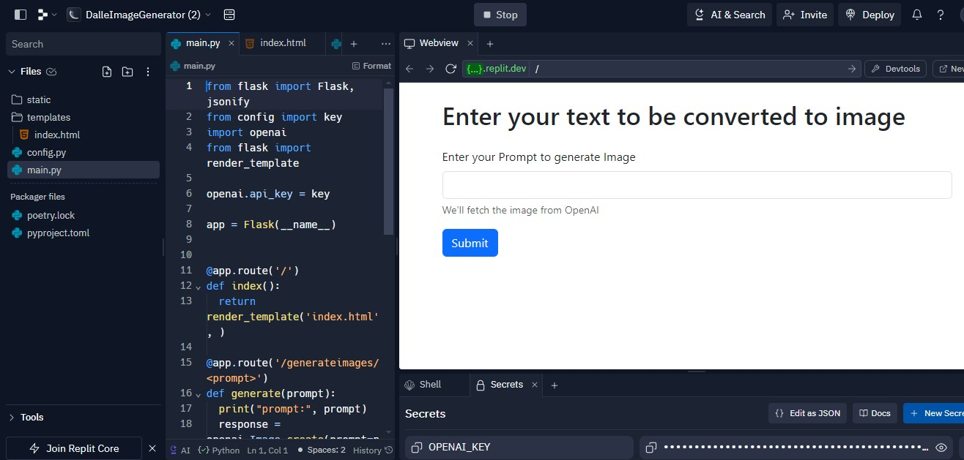
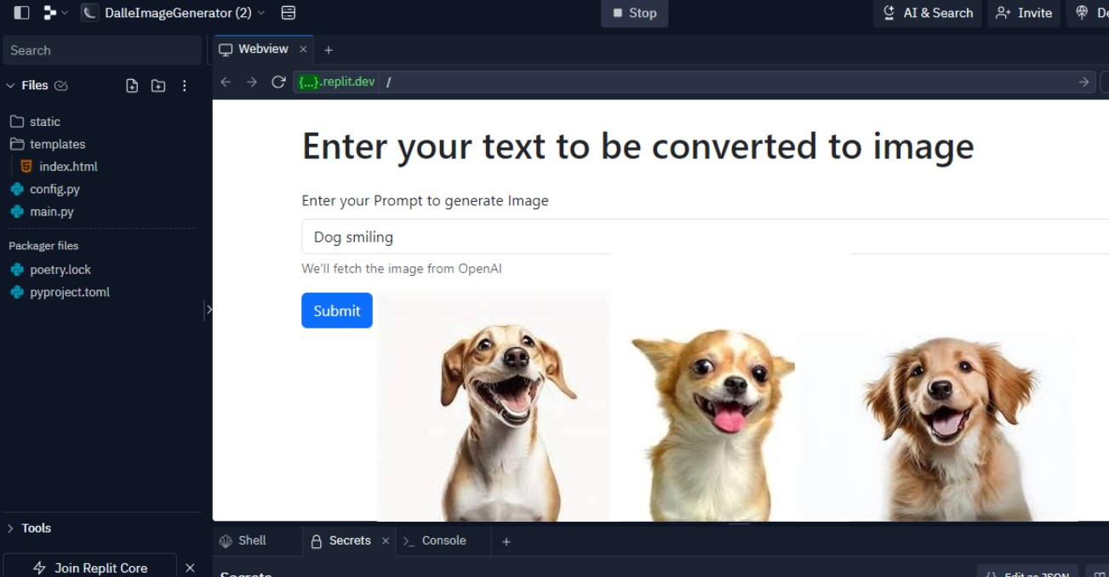

APPENDIX: Source code @github: https://github.com/Kannannair07/Gen_AI_Dall_E_image_generator

